Combining maps

In this chapter, you’ll learn:
- How to bring csv data with coordinates into your map.
- How to select features.
- How to join features based on geography using spatial join.

Data used:
- cadams.csv
- cacounties.shp
- UK.shp
- UK_rez.csv
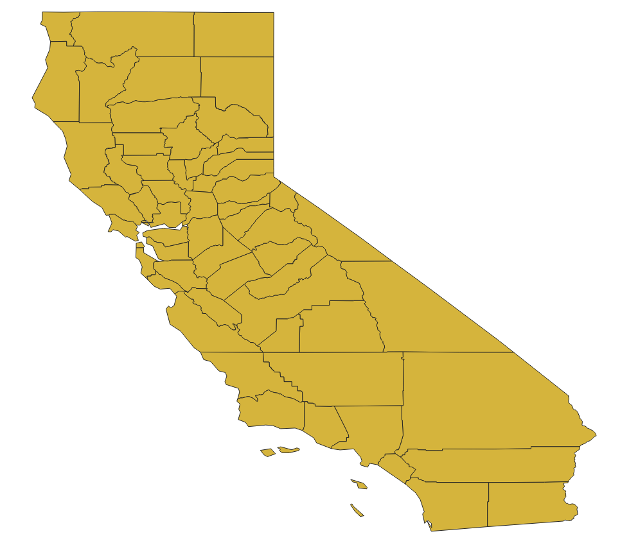
Everything we’ve done so far has used one map. The real power of mapping for stories is in combining maps to find patterns.

Let’s start a new map and bring in cacounties.shp. These are polygons of counties in California.

Often when we have a polygon layer, we’ll want to add a point or line layer. Let’s add data from the National Inventory of Dams, cadams.csv
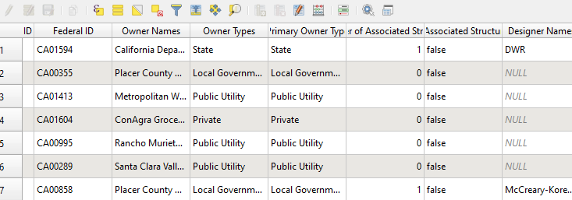
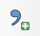
This data is not summarized by county, but it does contain location information – the latitude and longitude of each dam. Using that information, we can plot it on a map. We need to bring the data in by clicking “Add delimited txt.”
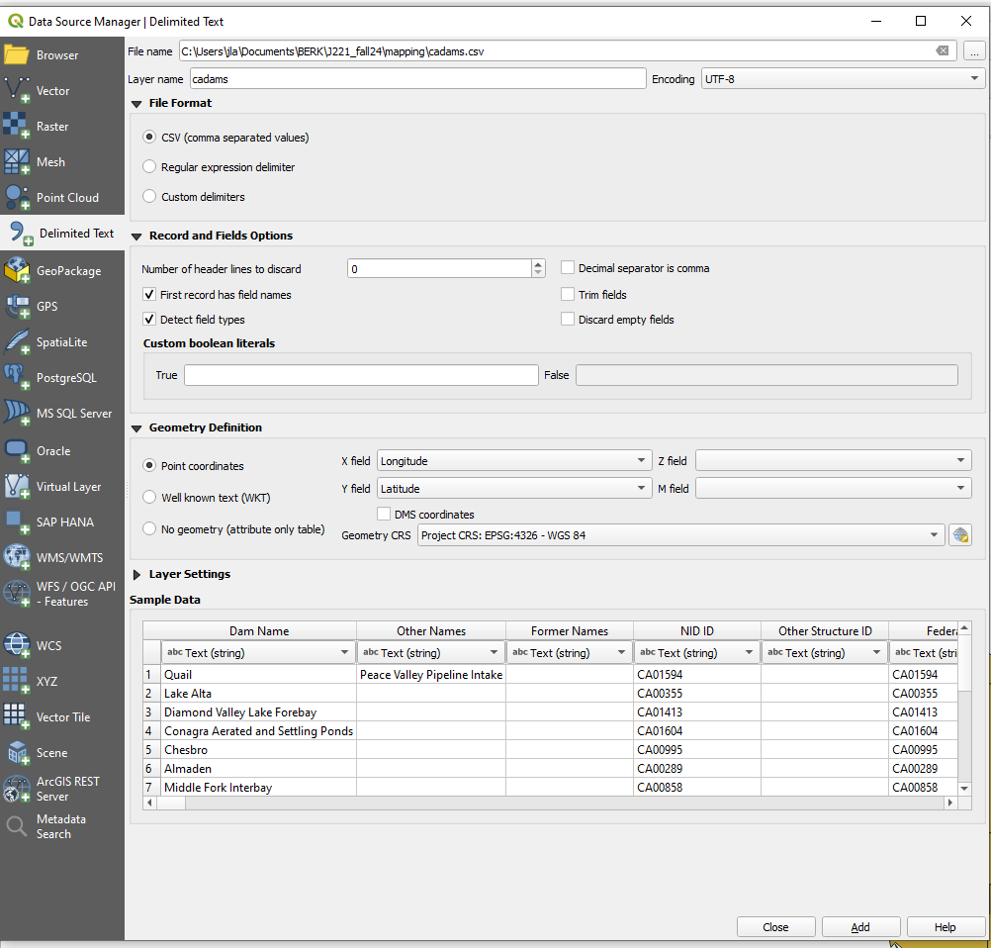

This time we need to tell QGIS that our data contains point coordinates. Choose Longitude for the X field and Latitude for the Y field. These are the names of those fields in our dam data.

I like to remember that X is longitude by visualizing that to make an X, I have to take a long step. I remember Y is latitude by thinking about doing lateral weight lifts. I’m sorry if now you cannot unsee those images. Keep in mind that future files might not have neatly named fields.

We also need to tell QGIS the Geometry CRS or Coordinate Reference System. We’ll get into this in the next chapter, but for now, let’s stick with the Project CRS.

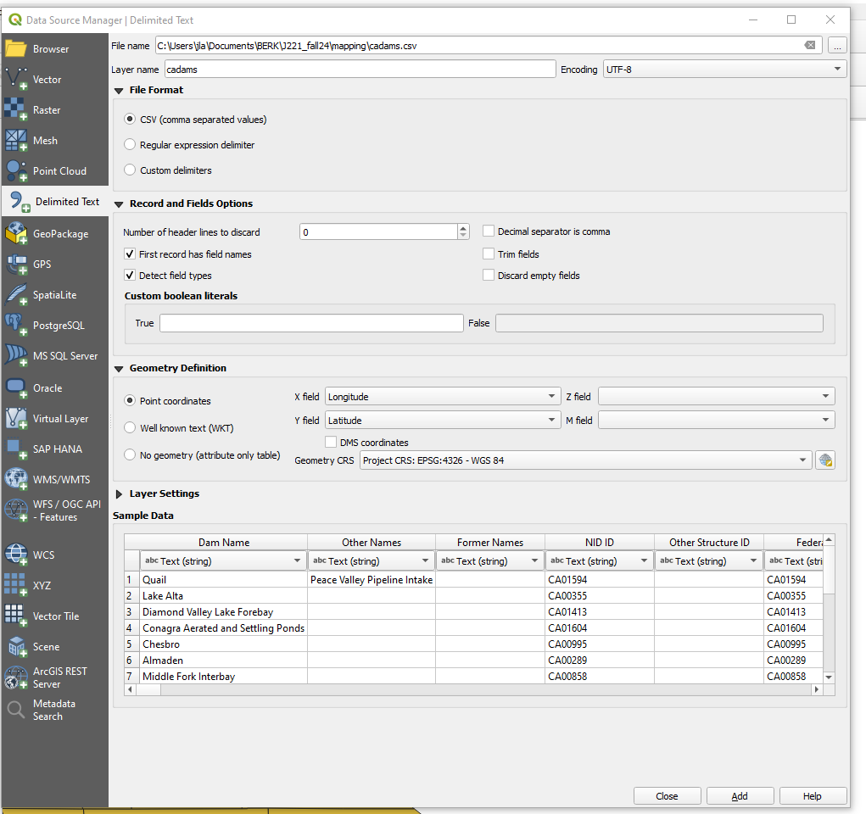

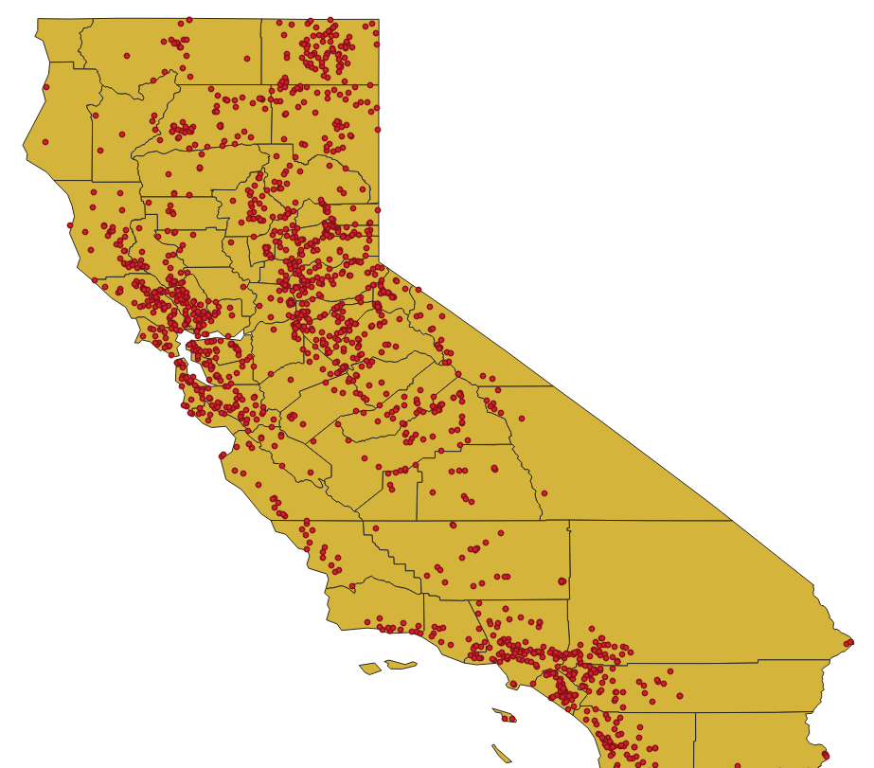
Click ADD and close. You should see the maps show up as points on your California counties map.

Let’s do some categorized mapping with the dams. There are A LOT of fields in this data. Two important fields are EAP, which indicates if the dam has an Emergency Action Plan; and Hazard, which indicates the possible risks if the dam were to breach:

High: Potential life lost
Significant: Potential property lost
Low: Neither of the above
blank - Who knows?

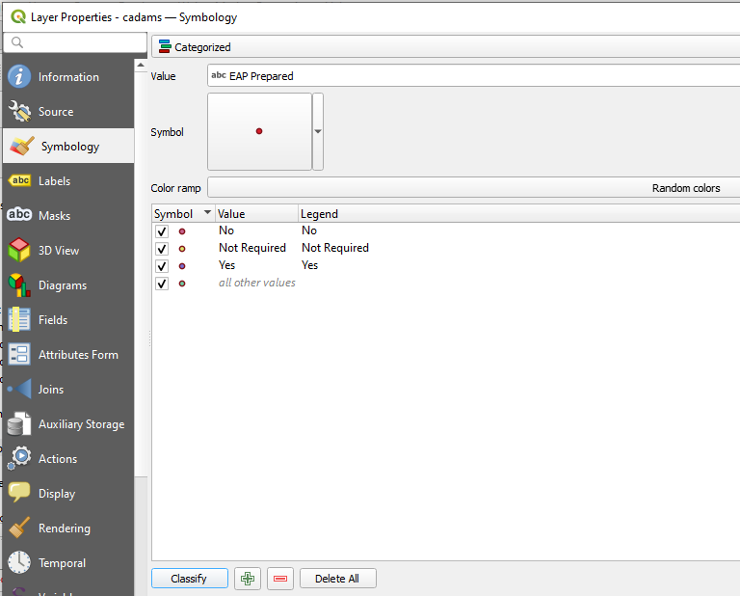
Let's start with EAP. Go to the Symbology TAB in the Properties for cadams. Choose Categorized from the drop-down menu.

Then the field EAP Prepared. Click classify at the bottom

You can change the colors or sizes of the dams by double-clicking on the dots.

You can use the symbology menu to pick what you want to see. If we want to just see the NO EAP dams, we could uncheck the others:
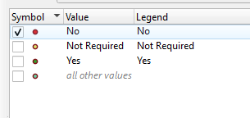

Now, try it for Hazard level - remember to click CLASSIFY at the bottom.
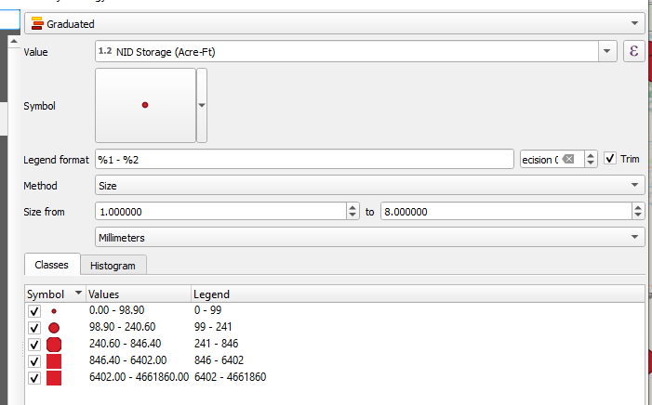

For numeric fields, dot size can illustrate value levels. Change symbology type to GRADUATED and the method to size. You can adjust the number of categories or sizes based on your mapping needs.

We’re just scratching the surface of what we can do with this data, but for now, SAVE THE PROJECT and we’ll practice with another data set.
Start a fresh new map (because QGIS is not good about cleaning up after itself.)

Bring in a map of UK unitary authorities by adding the file called UK.shp.
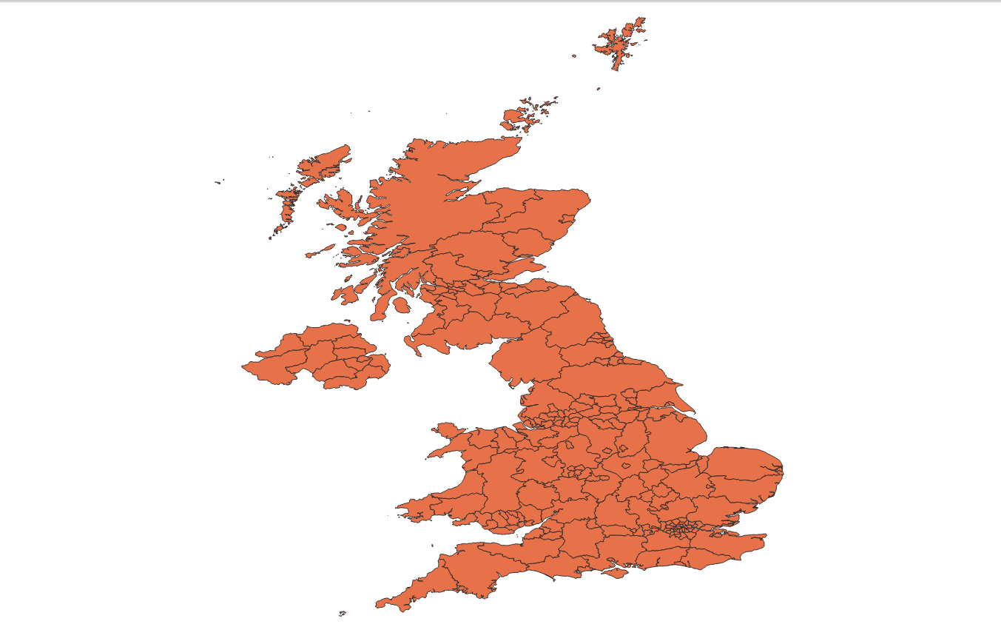

Take a look at the attribute table. It really just contains the geography information.

Let’s add some points to our map using uk_rez.csv. Remember to use Add delimited data. See if you can figure out the coordinate fields.

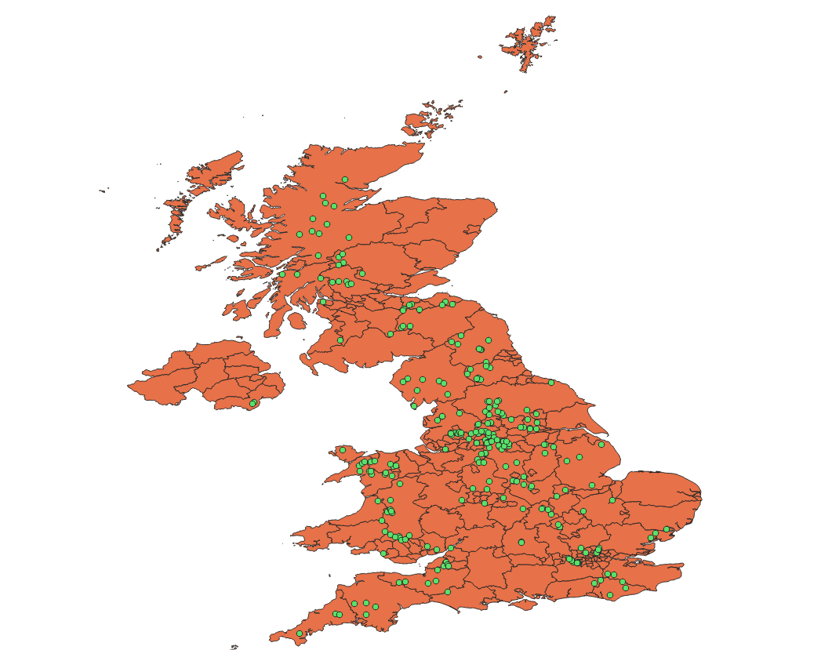
Just like we did with polygons or areas on the map, we can color-code points based on data in the attribute table. Let’s color by categorization using the INCEPTUSE field. This field designates the reservoir’s primary use. Here are what the codes mean:

WR=Water
FSA=Flood storage
D=Drainage
H=Hydroelectric power
P=Power
C=Canal
E=Environmental

SLICING MAPS FROM MAPS

Let’s say we just wanted a map of all the flood control reservoirs (FSA). We can do that using Selection.
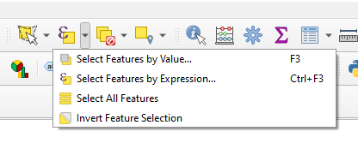
Find Select Features by Value on the main menu:

Choose Select Features by Expression.

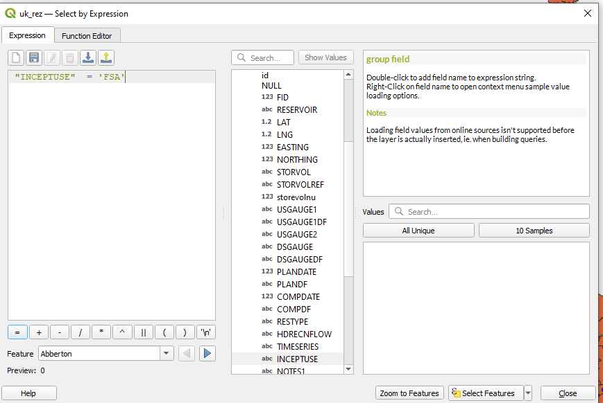
In the Select Features by Expression dialog box, find Fields and Values from the list in the middle. Click the arrow next to it to see all the fields in your data.

Double click on INCEPTUSE and it will pop it into the box to the left with “ “ quotes around it. Next, set the condition. Type: =’FSA’ Note that single quotes go around the condition.
Click Select Features.

If you don’t know the format of a field’s contents, you can choose “All unique” or “10 Samples” from the box in the lower right to see the field’s contents.

The FSA points will be highlighted yellow on the map and blue in the attribute table.
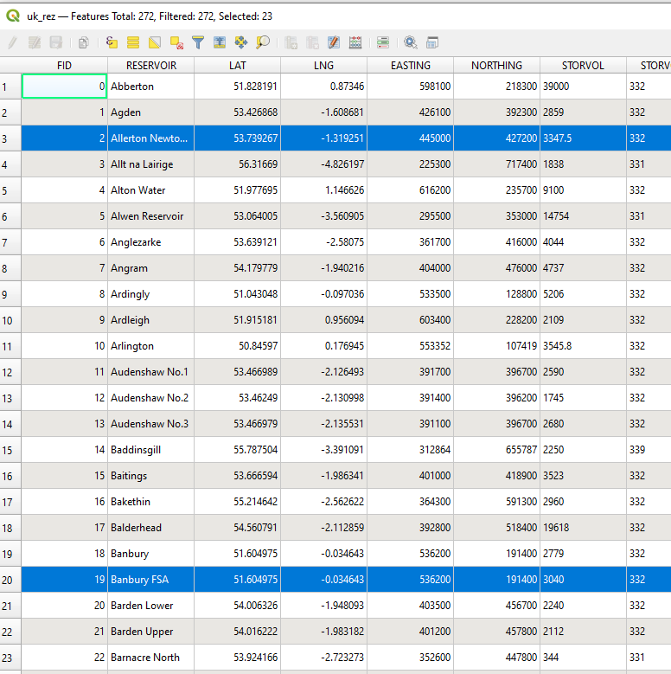
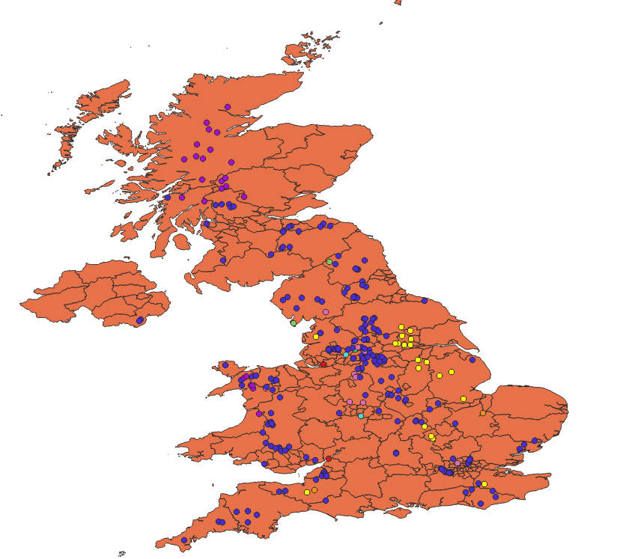

To see just the highlighted reservoirs in the table, choose Show Selected Features from the dropdown in the bottom left corner.
Close the attribute table. If we wanted to create a new shapefile that was just the FSA dams we can do that by right-clicking on the UK_rez layer and choosing Export | Save selected features as. Choose Esri shapefile from the first dropdown and navigate to where you are saving your mapping data and give the file the name FSA_rez.shp

ON YOUR OWN: Select WR reservoirs and make a new layer.

SUMMARIZING YOUR DATA

One powerful aspect of GIS is spatial joining. This is how stories that reveal intersections across data are done. I used it to find building permits on landslides. The Miami Herald used it to find homes that were damaged in the lowest wind speed area.

The reservoir data doesn’t contain county codes, but because we have them on a map with counties, we can aggregate them geographically. We’re going to count how many reservoirs are in each polygon. To do that click on the main menu Vector | Analysis Tools | Count Points in Polygons.

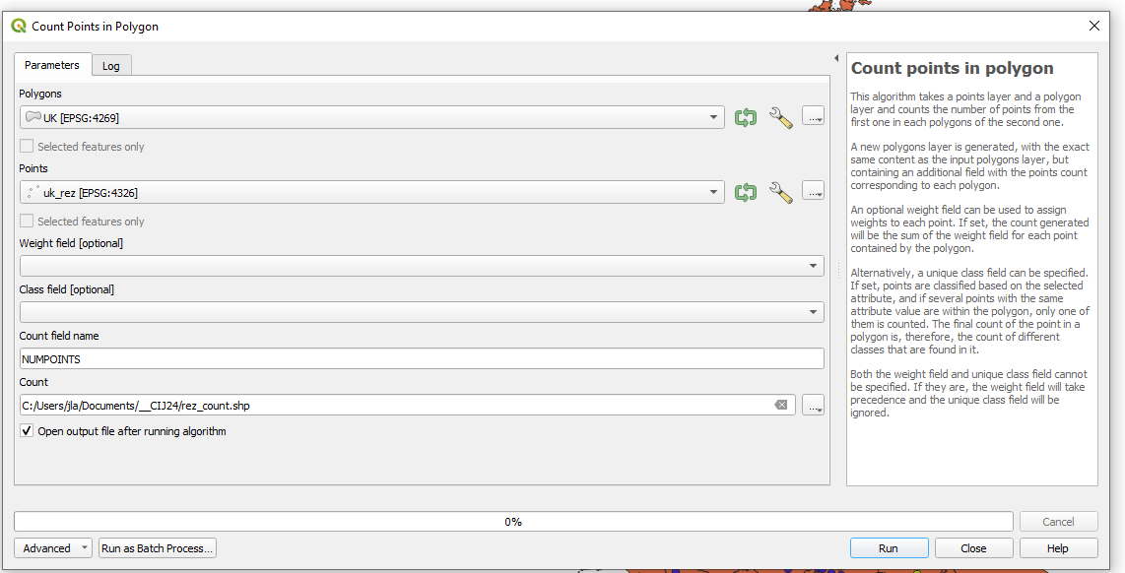

The polygon is UK. The points is uk_rez. The count field name is NUMPOINTS. Click on the … in the Count option and give it a new file name.

It will create a new layer that adds a column called NUMPOINTS to the UK layer. If you click on the header for the count column, you can sort it to see which county has the most reservoirs.

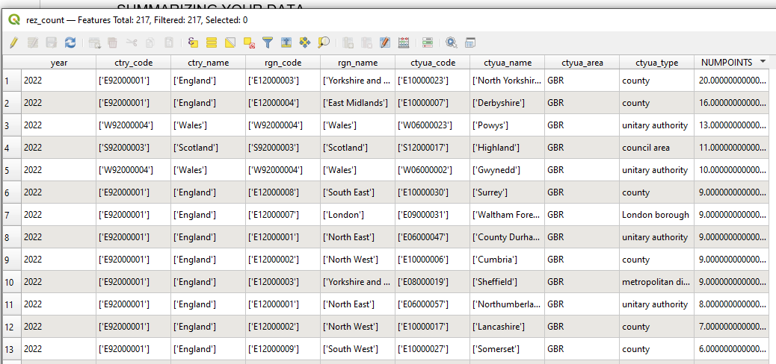

ON YOUR OWN

Go back to your California dams map. Create a new layer for High Hazard dams. How many don’t have an EAP? Do a spatial join to find which county has the most High Hazard dams.

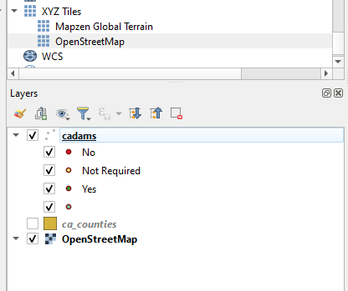
ADDING BASE MAPS

If you want to add a detailed map layer behind the data you’re mapping, you need a base map. There are lots of different ones, but the open-source one we’ll use is OpenStreetMap. To add it, scroll to the bottom of the browser window and click the arrow next to XYZ Tiles. Then drag OpenStreetMap into your layer window.
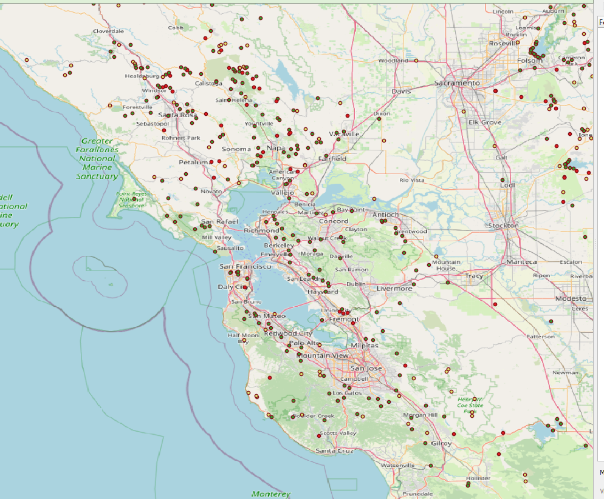

This is helpful in trying to locate details about your data. These are known as map tile layers because they are pictures that can’t be manipulated the same way shapefiles can be.

